Orators Report
on the 7th Degree
Provost and Judge
April 6, 2011
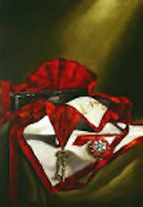

The apron of the 7th Degree is white and red, with a white and red rosette. A pocket holds the plans of the Temple. The jewel is a gold key which opens the box that holds the decisions of the tribunal.
Bremerton Valley of the Scottish Rite
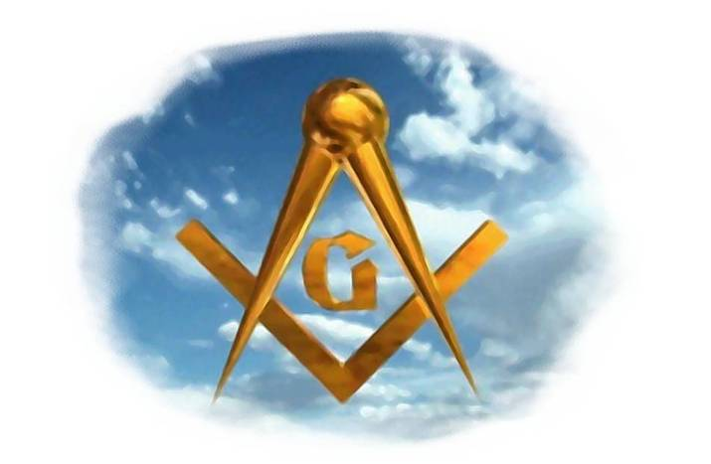
The Legend: The Blue Lodge 3rd degree is based on the legend of Hiram. This legend loosely has its historical basis in 1st Kings 4-7 and 2nd Chronicles 2-4. The Rites are based largely upon the Hiramic legend that follows after Hiram Abiff's death.
The ancient mythical Legend of the seventh degree, found in the old Rituals, is as follows:
After the death of Master Hiram, King Solomon appointed seven Provosts and Judges to administer justice among the workmen of the Temple. They were to adjust demands, listen to complaints and settle any disputes, administering the same laws to both Hebrew and Phoenician alike. The Chief Provost and Judge, Zabud, was entrusted with records of the tribunal.
The Setting: The site is the Temple of Solomon, under construction, in the Middle Chamber where the records are kept.
The Ritual: Zabud, as the Chief Provost and Judge, sits alone in deep thought. He is about to be approached by advocates of two sides of the same dispute, each seeking his favor on their behalf.
A friend, Naboth, enters explains that he governs the laborers who work on the south wall. Between him and the workmen a difference has arisen because he has hired Phoenician workmen, some of which are not of the Craft. Naboth expects difficulty to come before the judges. He requests Zabud to befriend him in the decision for which Naboth suggests he will use his influence with the king to advance Zabud's position. Zabud dismisses Naboth saying, "As a fellow of the Craft. I have called thee Brother; as a Judge, I know thee not."
Upon Naboth's exit, Uriah, a general laborer, enters. Uriah explains that the workmen on the south wall wish to remove all those Phoenician workmen. Zabud also dismisses Uriah. He chastises him for attempting to corrupt the judges by asking a judge to assume powers which are not his: that is, to show preference by arbitrarily dismissing all the Phoenicians, some of whom are of the craft.
The scene changes: The candidate, aspiring to the title of Provost and Judge, is now received as the character Zabud and is lectured on the virtues necessary to be a judge.
The candidate is invested with the cordon, jewel, and emblem of the degree. The triangle is explained as emblematical of the three great prerequisites of a judge: justice, equity, and impartiality.
The Lecture: Those who are entrusted to administer the law must do so without any personal consideration of the power of the mighty, the bribes of the rich, or the needs of the poor.
They must divest themselves of prejudice and preconception.
They must bear patiently, remember accurately, and weigh carefully the facts and the arguments offered before them.
They must not leap hastily to conclusions, or form opinions before they have heard all.
They must not presume crime or fraud.
They must neither be ruled by stubborn pride of opinion, nor be too facile and yielding to the view and arguments of others. In deducing the motive from the proven act, they must not assign to the act either the best or the worst motives, but those which they would think it just and fair for the world to assign to it, if they themselves had done it.
They must not endeavor to make many little circumstances, which weigh nothing separately, weigh much together, in an attempt to prove their own acuteness and sagacity.
Wrong and injustice once done cannot be undone by man, but are eternal in their Consequences; once committed, they are numbered with the irrevocable past.
Let the true Mason never forget the solemn injunction necessary to be obeyed at almost every moment of a busy life: "Judge not, lest you yourselves be judged; for whatsoever judgment you give to others, the same shall in turn be given to you. Such is the lesson taught to the Provost and Judge.

In a country where trial by jury is known, every intelligent man is liable to be called on to act as a judge, either of fact alone, or of fact and law mingled; and to assume the heavy responsibilities which belong to that character.
From the degree, we learn that impartial justice protects person, property, happiness and reputation. We are instructed to judge with patience and impartially.

THE MORAL TEACHING of this degree is JUSTICE, in decision and judgment, and in our intercourse and dealing with others, especially Masons.

DUTIES: Let justice be the guide of all your actions.

FOR REFLECTION: Are the duties of a judge a burden or an honor?

IMPORTANT SYMBOLS: Equal balance, ebony box that holds the records of the Tribunal, triangle, the color red.

Adapted from the Spanish version of Rex R. Hutchen’s book A Bridge to Light

